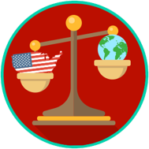
Why a Constitutional Republic?: SS.7.CG.3.2
Systems of Government
READING #3
Name: ________________________

Date: _________________________

SS.7.C.3.2 Benchmark Clarification 3: Students will recognize examples of these systems of government.

System of Government | Example
Federal | The United States’ national government consists of an elected President, Congress, and a Supreme Court. The United States has 50 individual states, each with their own constitution. State governments also have legislative, executive, and judicial powers. The central government shares powers with the state governments.
Confederal | The first government formed by the colonists after winning independence was done so under the Articles of Confederation. This was a loose friendship among the states with little to no power given to a central government.
Unitary | Prior to declaring independence, colonists were under British rule. The central government consisted of a king and parliament. Colonists and their local governing bodies had little to no say over things such as taxes.

confederal system - a system of government where power is located with the independent states and there is little power in the central government
federal system - a system of government where power is shared between a central government and states
legislative - the power of government to make laws
unitary system - a system of government where almost all power is located with the central government

