FL State & Local Government: SS.7.C.3.4
Federalism
VOCABULARY PRACTICE
Name: ______________________

Date: _______________________
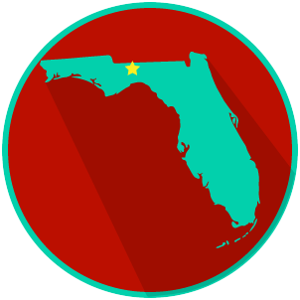

Federalism

Write about your understanding of federalism by explaining the connections between and among each of the terms in the concept circle.

How do the terms in the concept circle fit together?

