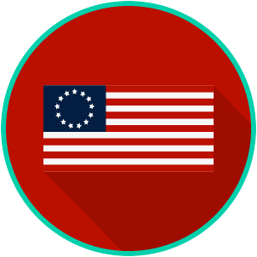
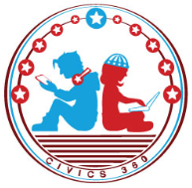
The Founding: SS.7.C.1.5
Articles of Confederation
VIDEO VIEWING GUIDE
Name: ________________________________

Date: _________________________________

Question | List Specific Evidence from the Video | Complete Sentence
1. What type of system of government was established under the Articles of Confederation?

2. Describe the relationship between states and the central government in a confederal system.

3. Summarize the first two weaknesses of the Articles of Confederation.
4. Summarize the weaknesses of the Articles of Confederation.
5. What was Shays’s Rebellion?

6. How did Shays’s Rebellion help lead to the writing of the U.S. Constitution?
7. What occurred at the 1787 Constitutional Convention?

Extra Notes Section

Name: ________________________

Date: _________________________
The Founding: SS.7.C.1.5
Articles of Confederation
READING GUIDE
Reading: Weaknesses of the Articles of Confederation

Benchmark Clarification: Students will identify the weaknesses of the government under the Articles of Confederation (i.e., Congress had no power to tax, to regulate trade, or to enforce its laws; the national government lacked a national court system [judicial branch] and central leadership [executive branch]; and changes to the Articles required unanimous consent of the 13 states).

Reading Task | Response
What ideas are presented in the reading?
What is the central idea of the reading?
Select two words or phrases that support the central idea.
How might this reading connect to your own experience or something you have seen, read, or learned before?
What were the weaknesses of the Articles of Confederation?

Which weakness do you think was the most important and why?

The Founding: SS.7.C.1.5
Articles of Confederation
VOCABULARY PRACTICE
Name: ________________________

Date: _________________________
Weaknesses of the Articles of Confederation

Write about your understanding of how the weaknesses of the Articles of Confederation led to the U.S. Constitution by explaining the connections between and among each of the terms in the concept circle.

How do the terms in the concept circle fit together?

The Founding: SS.7.C.1.5
Articles of Confederation
PRACTICE QUIZ
Name: ________________________

Date: _________________________
Articles of Confederation Practice Quiz Reflection

FIRST Attempt Score | I answered ______ questions right.
One thing I learned:

SECOND Attempt Score | I answered ______ questions right.
One thing I learned:

