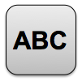
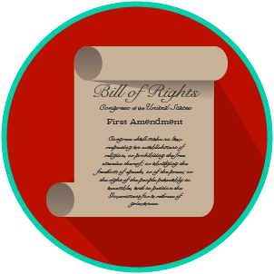
My Rights & Liberties: SS.7.C.2.4
The Bill of Rights and
Other Amendments
VOCABULARY PRACTICE
Name: _______________________

Date: ________________________

The Bill of Rights and Other Amendments

Write about your understanding of constitutional rights by explaining the connections between and among each of the terms in the concept circle.

How do the terms in the concept circle fit together?

