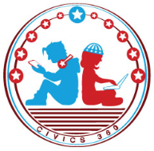
Federal Government: SS.7.CG.1.10
Federalists versus
Anti-Federalists
VIDEO VIEWING GUIDE #1
Name: ________________________________

Date: _________________________________

Federalists vs. Anti-Federalists Video #1
Question | List Specific Evidence from the Video | Complete Sentence
1. Which system of government does the United States have as a result of the U.S Constitution?

2. Which system of government did the United States have under the Articles of Confederation?

3. Based on their views, what are the two groups of men that worked to craft the Constitution called?
4. How did the Federalists share their ideas about the Constitution?
5. What did the Federalists believe the new Constitution would do?

6. Which Enlightenment ideas did the Federalists believe would keep the government from getting too powerful?

7. Why did the Federalists oppose a bill of rights?

8. What did the Anti- Federalists believe?

9. How did the Anti- Federalists share their ideas about the Constitution?
10. Why did the Anti- Federalists want a bill of rights?

