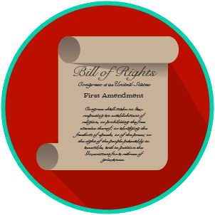
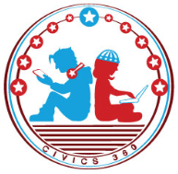
My Rights & Liberties: SS.7.C.3.6
Constitutional Rights and Their Impact
VIDEO VIEWING GUIDE #2
Name: ________________________________

Date: _________________________________

Impact of Constitutional Rights Video #2
Question | List Specific Evidence from the Video | Complete Sentence
1. What are some of the rights and protections included in the Constitution, Bill of Rights, and other Amendments?
2. What is due process?

3. How does the government balance individual liberties and rights with community protections?
4. When might it be necessary to limit individual rights and liberties?
5. What is habeas corpus?
6. How did Hosea Williams and John Lewis practice their rights?

7. What rights were Williams, Lewis, and the Selma Marchers practicing in 1965?

8. How did Executive Order 9066 impact American citizens?

9. Why is Fred Korematsu significant?
10. What was the outcome of Korematsu vs. United States? (1944)
11. Give an example of how the Constitution protects individual rights.
12. When might the government impose limits on individual rights?

