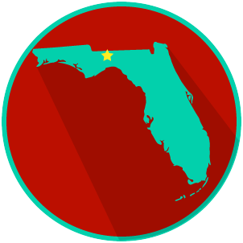
FL State & Local Government:
SS.7.C.3.4
Federalism
READING GUIDE #1
Name: ______________________

Date: _______________________

Reading: Defining Federalism

Benchmark Clarification 1: Students will define the system of federalism.

Reading Task | Response
What ideas are presented in the reading?
What is the central idea of the reading?
Select two words or phrases that support the central idea.
How might this reading connect to your own experience or something you have seen, read, or learned before?
Define the system of federalism.

