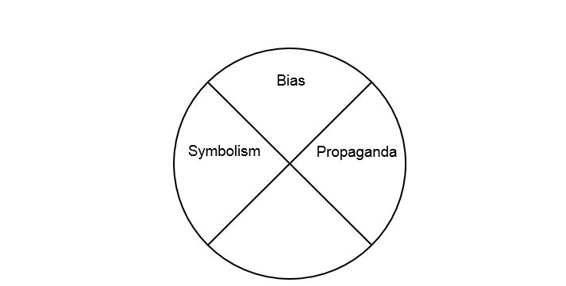
SS.7.C.2.11-Bias, Symbolism, and Propaganda
Vocabulary Practice
Write about our understanding of media and political communication by explaining the connections between and among each of the terms in the concept circle. How do the terms in the concept circle fit together?
________________________________________________________________________________________________________________________________________________________________________________________________________________________________________________________________________________________________________________________________________________________________________________________________________________________________________________________________________________________________________________________________________________________________________________________________________________________________________________________________________________________________________________________________________________________________________

