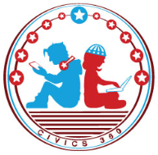
Federal Government: SS.7.CG.1.10
Federalists versus
Anti-Federalists
VIDEO VIEWING GUIDE #2
Name: ________________________________

Date: _________________________________

Federalists vs. Anti-Federalists Video #2
Question | List Specific Evidence from the Video | Complete Sentence
1. What are three things the Federalists and Anti-Federalists disagreed on in the proposed Constitution?
2. What is the purpose of the necessary and proper (or elastic) clause within the Constitution?
3. Why was this clause a concern to the Anti- Federalists?
4. Why did the Anti- Federalists reject the Federalists’ argument about including a bill of rights?

5. How is the ratification of the Constitution an example of a compromise?

Additional Notes:

