High School U.S. Government Classroom  The United States Constitution  VIDEO VIEWING GUIDE #1 | 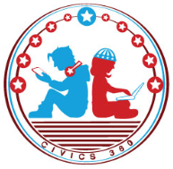  Name: ______________  Date: _______________

Question | List Specific Evidence  from the Video | Complete Sentence
1.What was the original intention of the Constitutional Convention of 1787?

2. What is the purpose of the checks and balances within the U.S. Constitution?

3. What is an example of checks and balances in the U.S. Constitution?
4. Complete the table:

Federalism and Power under the U.S. Constitution
Level of Government | Type of Power | Example of Power
Federal

 | Concurrent
State

 | From State Constitutions

5. Which constitutional principle suggests that legislative, executive, and judicial powers should function independently of each other?
6. What constitutional principle does this cartoon symbolize?
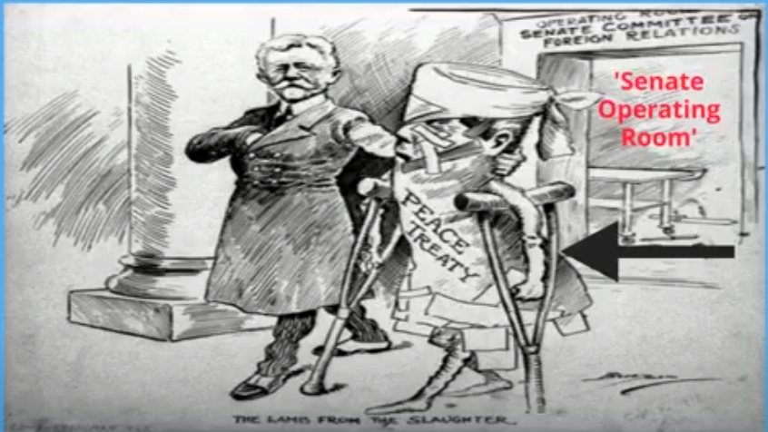
‘The Lamb from the Slaughter’ by, Clifford K. Berryman
7. States have the power to run elections, while the federal government has the power to coin money. What structural constitutional principle is this an example of?
8. How does this cartoon illustrate separation of powers?
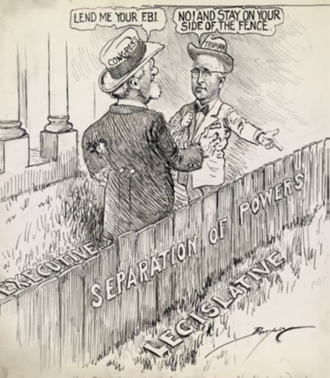
“Hope This Won’t Develop Into a Neighborhood Feud” by, Clifford K. Berryman

