The Three Branches of Government
The Executive Branch
- I can understand the processes of the executive branch.
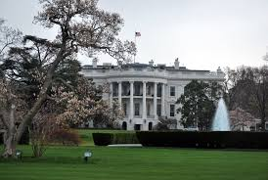
The executive branch is made up of the president, vice president and executive agencies and departments. The main job of the executive branch is to enforce laws or make sure everyone is following the laws that were created by the legislative branch. There are many types of agencies and departments in the executive branch and they ensure that all laws are being properly followed. The executive branch the largest of the three branches.
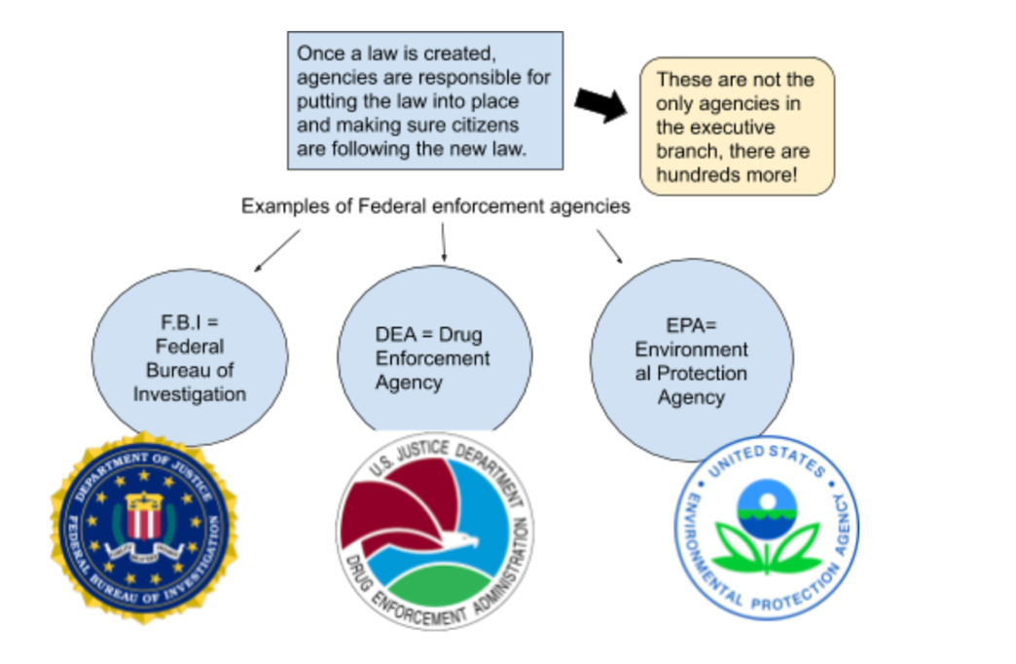
Article II of the Constitution outlines the powers of the president. If a bill does become a law, the president as chief executive of the country must make sure that laws passed by Congress are enforced.

Some Other Powers of the Executive Branch:
Executive Orders
- The president has the power to issue executive orders, these orders have the power of a law.
  - For example, an executive order signed by President Franklin Roosevelt in 1942 allowed the forced internment of U.S. citizens of Japanese descent during World War II.
  - Executive orders DO NOT have to be approved by Congress, although the U.S. Supreme Court may find them to be unconstitutional and strike them down. This is part of our checks and balances system.
Nominations
- The president has the power to nominate or choose people to serve in different government positions. These are known as presidential appointments.
  - Some appointed positions include: the president’s cabinet, U.S. Supreme Court justices, and ambassadors to different countries.
  - As a part of the checks and balances system, the Senate must approve presidential appointments. This is a check on the president’s power to nominate people who may not be qualified for a certain position or who may have problems that would keep them from being effective in their position.

