The Three Branches of Government
The Judicial Branch
- I can understand the processes of the judicial branch.
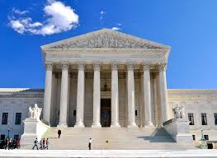
The judicial branch of government includes the Supreme Court, federal courts, and state courts. Article III of the U.S. Constitution outlines the court structure. The U.S. Supreme Court is the highest court in the nation. In most cases, the Supreme Court has appellate jurisdiction, which means it has the power to review cases that have already been decided in lower courts. Sometimes the U.S. Supreme court has original jurisdiction, which means the Court has the power to hear a case first. For example, cases involving disagreements between two states would be first heard by the U.S. Supreme Court.
U.S Supreme Court
Let’s look at the appellate process.

There are thousands of requests for appeals to be heard by the Supreme Court each year. Fewer than 100 are likely to be accepted. Once the Supreme Court reviews an appeal, the Court decides whether or not to hear the case. The Court will issue a writ of certiorari if the Court decides to accept the case.
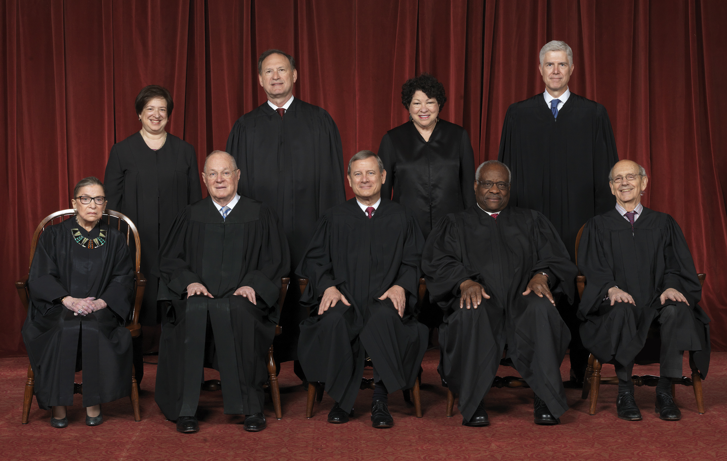
Many cases that are accepted by the Supreme Court deal with constitutional questions. The Supreme Court has the power to review these questions because they have the power of judicial review. Judicial review is the power of the judicial branch to review the actions of the executive and legislative branches and determine whether or not they are unconstitutional (this includes laws passed by Congress). This power is not included in the U.S. Constitution, the U.S. Supreme Court case Marbury v. Madison established this power.
U.S Supreme Court Justices

