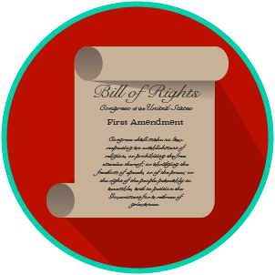
My Rights & Liberties: SS.7.C.3.6
Constitutional Rights and Their Impact
READING GUIDE #1
Name: _______________________

Date: ________________________

Reading: Rights and Participation

Benchmark Clarification 1: Students will recognize how individual rights shape involvement in the social, political, and economic systems.

Reading Task | Response
What ideas are presented in the reading?
What is the central idea of the reading?
Select two words or phrases that support the central idea.
How might this reading connect to your own experience or something you have seen, read, or learned before?
How do individual rights shape involvement in social, political, and economic systems? | Individual rights shape involvement in social, political, and economic systems by:

