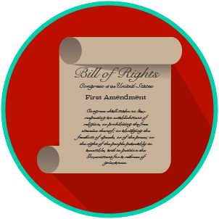
My Rights & Liberties: SS.7.C.3.6
Constitutional Rights and Their Impact
READING GUIDE #2
Name: _______________________

Date: ________________________

Reading: Society and the Importance of Rights

Benchmark Clarification 2: Students will recognize how the social, political, and economic systems in the United States are dependent upon individual rights.

Reading Task | Response
What ideas are presented in the reading?
What is the central idea of the reading?
Select two words or phrases that support the central idea.
How might this reading connect to your own experience or something you have seen, read, or learned before?
Why do individual rights matter in the United States? | Individual rights matter in the US because:

