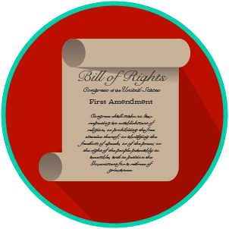
My Rights & Liberties: SS.7.C.3.6
Constitutional Rights and Their Impact
READING GUIDE #3
Name: _______________________

Date: ________________________

Reading: Constitutional Rights Scenarios

Benchmark Clarification 3: Students will use scenarios to recognize and/or evaluate options for exercising constitutional rights.

Reading Task | Response
What ideas are presented in the reading?
What is the central idea of the reading?
Select two words or phrases that support the central idea.
How might this reading connect to your own experience or something you have seen, read, or learned before?
Create a scenario of your own that shows how we can exercise our constitutional rights.

