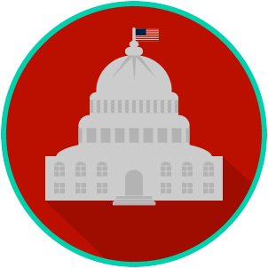
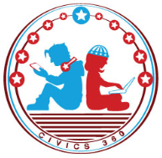
Federal Government: SS.7.C.3.3
Articles I, II, and III
VIDEO VIEWING GUIDE
Name: ________________________________

Date: _________________________________

Question | List Specific Evidence from the Video | Complete Sentence
1.What do the Articles in the U.S. Constitution describe?

2. Which article of the U.S. Constitution describes the legislative branch?

3. Describe the structure of the legislative branch.
4. What are the houses of legislative branch?
5. What are some of the enumerated powers of Congress?

6. According to Article I of the Constitution, what is the main role and responsibility of Congress?

7. Which article of the U.S. Constitution describes the executive branch?

8. Describe the structure of the executive branch.

9. What are the powers of the President?
10. According to Article II of the U.S. Constitution, what is the main role and responsibility of the executive branch?

11. Which article of the U.S. Constitution describes the judicial branch?
12. Describe the structure of the judicial branch.

13. How can Congress impact the judicial branch?

14. What is the main role and responsibility of the judicial branch?

15. What are the powers of the Supreme Court?

16. What does it mean when it is said that the Supreme Court addresses issues around constitutionality?

Don’t stop now! Complete the “Let’s Compare!” chart below.
Write the structure and main responsibility for each branch of government.

Let’s Compare!
 | Legislative Branch | Executive Branch | Judicial Branch
Structure
Main Responsibility

Name: _______________________

Date: ________________________
Federal Government: SS.7.C.3.3
Articles I, II, and III
READING GUIDE #1
Reading: The Structure of the Three Branches of Government

Benchmark Clarification 1: Students will recognize the structure of the legislative, executive, and judicial branches.

Reading Task | Response
What ideas are presented in the reading?
What is the central idea of the reading?
Select two words or phrases that support the central idea.
How might this reading connect to your own experience or something you have seen, read, or learned before?
Explain how the three branches of government are organized. | The three branches of government are organized by:

Name: _______________________

Date: ________________________
Federal Government: SS.7.C.3.3
Articles I, II, and III
READING GUIDE #2
Reading: Roles and Responsibilities of the Three Branches of Government

Benchmark Clarification 2: Students will compare the roles and responsibilities of the three branches of the federal government.

Reading Task | Response
What ideas are presented in the reading?
What is the central idea of the reading?
Select two words or phrases that support the central idea.
How might this reading connect to your own experience or something you have seen, read, or learned before?
Describe the roles and responsibilities of each of the three branches of government. | The legislative branch:
 | The executive branch:
 | The judicial branch:

Name: _______________________

Date: ________________________
Federal Government: SS.7.C.3.3
Articles I, II, and III
READING GUIDE #3
Reading: The Powers of the Three Branches of Government

Benchmark Clarification 3: Students will identify the general powers described in Articles I, II, and III of the U.S. Constitution.

Reading Task | Response
What ideas are presented in the reading?
What is the central idea of the reading?
Select two words or phrases that support the central idea.
How might this reading connect to your own experience or something you have seen, read, or learned before?
Describe in your own words at least two powers contained in Articles I, II, and III of the Constitution. | Article I:
 | Article II:
 | Article III:

Federal Government: SS.7.C.3.3
Articles I, II, and III
VOCABULARY PRACTICE
Name: _______________________

Date: ________________________

Articles I, II, and III of the U.S. Constitution

Write about your understanding of the structure and function of the three branches of government by explaining the connections between and among each of the terms in the concept circle.

How do the terms in the concept circle fit together?
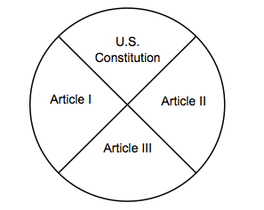

Federal Government: SS.7.C.3.3
Articles I, II, and III
PRACTICE QUIZ
Name: _______________________

Date: ________________________
Articles I, II, and III of the U.S. Constitution Practice Quiz Reflection

FIRST Attempt Score | I answered ______ questions right.
One thing I learned:

SECOND Attempt Score | I answered ______ questions right.
One thing I learned:

