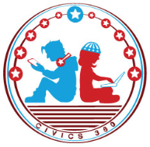
Citizen You: SS.7.CG.1.11
The Rule of Law
VIDEO VIEWING GUIDE
Name: ________________________________

Date: _________________________________

Question | List Specific Evidence from the Video | Complete Sentence
1. What is the Rule of Law?

2. What is the purpose of separation of powers and checks and balances?

3. What role does the Constitution and its amendments play in ensuring that the United States has the rule of law?
4. What is due process and how does it work with rule of law?
5. How does the rule of law impact government officials?
6. What role does an independent judiciary (court system) play in the rule of law?

7. Why is serving on a jury important to ensuring the rule of law?
8. What would life be like if we did not have the rule of law?

9. Does the President of the United States have to follow the laws of the country?

Extra Notes Section

