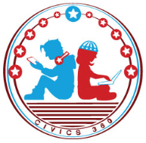
The Founding: SS.7.CG.1.5
The Road to Independence
VIDEO VIEWING GUIDE #4
Name: ________________________________

Date: _________________________________
The Tea Act and The Intolerable Acts Video #4
Question | List Specific Evidence from the Video | Complete Sentence
1. What was the Tea Act?
2. How did the colonists respond to the Tea Act?

3. Summarize the Intolerable Acts.
4. How did the colonists react to the Intolerable Acts?
5. What was Common Sense?

