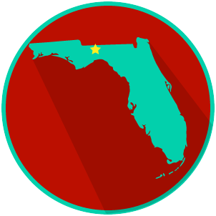
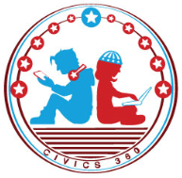
FL State & Local Government: SS.7.C.3.14
State and Local Government
Obligations and Services
VIDEO VIEWING GUIDE
Name: ______________________________

Date: _______________________________

Question | List Specific Evidence from the Video | Complete Sentence
1. What kind of power is listed in Article I, Section 8 of the Constitution?

2. What is meant by ‘enumerated powers’?

3. What kind of power is mentioned in the Tenth Amendment to the U.S. Constitution?
4. What is meant by ‘reserved powers’?
5. What are examples of reserved powers?

6. What are concurrent powers?
7. What are examples of concurrent powers?
8. What kinds of services do state tax dollars provide?
9. Scenario: You have just moved from Casper, Wyoming to Tallahassee, Florida and you need a driver’s license.

Which level of government would you contact to get your driver’s license?
10. Why do local governments provide more services to the people than state or federal government?
11. What kinds of services do local governments provide?
12. Scenario: You wake up late for school because your alarm did not go off. Your alarm did not go off because the power in your home has been shut off.

Which level of government do you contact to solve this problem?

FL State & Local Government: SS.7.C.3.14
State and Local Government Obligations and Services
READING GUIDE #1
Name: ______________________

Date: _______________________

Reading: Government Services Scenarios

Benchmark Clarification 1: Students will evaluate scenarios in order to determine which level of government provides specific services.

Reading Task | Response
What ideas are presented in the reading?
What is the central idea of the reading?
Select two words or phrases that support the central idea.
How might this reading connect to your own experience or something you have seen, read, or learned before?
Create a scenario of your own that shows which level of government would provide a specific service of your choice.

FL State & Local Government: SS.7.C.3.14
State and Local Government Obligations and Services
READING GUIDE #2
Name: ______________________

Date: _______________________

Reading: Grouping Services by Level of Government

Benchmark Clarification 2: Students will classify government services according to level of government in order to evaluate the role that each plays in their lives.

Reading Task | Response
What ideas are presented in the reading?
What is the central idea of the reading?
Select two words or phrases that support the central idea.
How might this reading connect to your own experience or something you have seen, read, or learned before?
Based on what you have read and learned, which level of government do you believe has the most important role in your daily life and why? | The level of government that has the most important role in my daily life is ________________________ because:

FL State & Local Government: SS.7.C.3.14
State and Local Government Obligations and Services
READING GUIDE #3
Name: ______________________

Date: _______________________

Reading: Obligations of Government

Benchmark Clarification 3: Students will compare the obligations/powers of governments at each level.

Reading Task | Response
What ideas are presented in the reading?
What is the central idea of the reading?
Select two words or phrases that support the central idea.
How might this reading connect to your own experience or something you have seen, read, or learned before?
Based on your reading, where do we find the obligations of the federal government listed?  What about state governments? | We can find the obligations of the federal government and of state governments in:

FL State & Local Government: SS.7.C.3.14
State and Local Government Obligations and Services
READING GUIDE #4
Name: ______________________

Date: _______________________

Reading: Comparing Powers of Government

Benchmark Clarification 4: Students will compare the reserved, concurrent and expressed/enumerated powers of government.

Reading Task | Response
What ideas are presented in the reading?
What is the central idea of the reading?
Select two words or phrases that support the central idea.
How might this reading connect to your own experience or something you have seen, read, or learned before?
Explain the difference between reserved, concurrent, and expressed/enumerated powers and give an example of each. | Reserved powers
 | Concurrent powers
 | Expressed/Enumerated powers

FL State & Local Government: SS.7.C.3.14
State and Local Government Obligations and Services
VOCABULARY PRACTICE
Name: ______________________

Date: _______________________
State and Local Government Obligations and Services

Write about your understanding of state and local government obligations and services by explaining the connections between and among each of the terms in the concept circle.

How do the terms in the concept circle fit together?
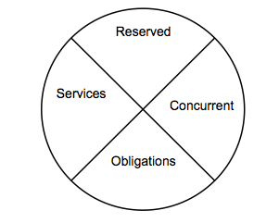

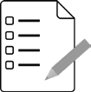
FL State & Local Government SS.7.C.3.14
State and Local Government Obligations and Services
PRACTICE QUIZ
Name: _______________________

Date: ________________________

State and Local Government Obligations and Services Practice Quiz Reflection

FIRST Attempt Score | I answered ______ questions right.
One thing I learned:

SECOND Attempt Score | I answered ______ questions right.
One thing I learned:

