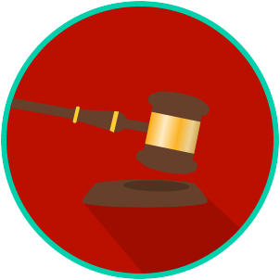
The Legal System: SS.7.C.3.11/C.2.6
State & Federal Courts
READING GUIDE #1
Name: _____________________

Date: ______________________
Reading: Levels, Functions and Powers of Courts

Benchmark Clarification 1: Students will distinguish between the levels, functions, and powers of courts at the state and federal levels.

Reading Task | Response
What ideas are presented in the reading?
What is the central idea of the reading?
Select two words or phrases that support the central idea.
How might this reading connect to your own experience or something you have seen, read, or learned before?
How does the concept of jurisdiction impact the powers and functions of the courts at the state and federal levels? | Jurisdiction impact the powers and functions of the courts at the state and federal levels by:

