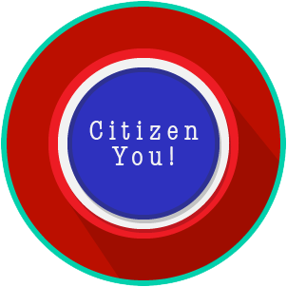
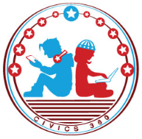
Citizen You: SS.7.C.1.9
The Rule of Law
VIDEO VIEWING GUIDE
Name: ________________________________

Date: _________________________________

Question | List Specific Evidence from the Video | Complete Sentence
1. What is the Rule of Law?

2. What is the purpose of separation of powers and checks and balances?

3. What role does the Constitution and its amendments play in ensuring that the United States has the rule of law?
4. How does the rule of law impact government officials?
5. What role does an independent judiciary (court system) play in the rule of law?

6. Why is serving on a jury important to ensuring the rule of law?
7. What would life be like if we did not have the rule of law?

8. Does the President of the United States have to follow the laws of the country?

Extra Notes Section

Name: ________________________

Date: _________________________
Citizen You: SS.7.C.1.9
The Rule of Law
READING GUIDE #1
Reading: Life Without the Rule of Law

Benchmark Clarification 1: Students will distinguish between the characteristics of a society that operates under the rule of law and one that does not.

Reading Task | Response
What ideas are presented in the reading?
What is the central idea of the reading?
Select two words or phrases that support the central idea.
How might this reading connect to your own experience or something you have seen, read, or learned before?
How does a society that operates under the rule of law differ from one that does not? | A society that operates under the rule of law differs from one that does not by:

Name: ________________________

Date: _________________________
Citizen You: SS.7.C.1.9
The Rule of Law
READING GUIDE #2
Reading: The Importance of the Rule of Law

Benchmark Clarification 2: Students will assess the importance of the rule of law in protecting citizens from arbitrary and abusive uses of government power.

Reading Task | Response
What ideas are presented in the reading?
What is the central idea of the reading?
Select two words or phrases that support the central idea.
How might this reading connect to your own experience or something you have seen, read, or learned before?
How does the rule of law protect citizens? | The rule of law protects citizens by:

Name: ________________________

Date: _________________________
Citizen You: SS.7.C.1.9
The Rule of Law
READING GUIDE #3
Reading: The Impact of the Rule of Law

Benchmark Clarification 3: Students will evaluate the impact of the rule of law on governmental officials and institutions (accountability to the law, fair procedures, decisions based on the law, consistent application, enforcement of the law, and transparency of institutions).

Reading Task | Response
What ideas are presented in the reading?
What is the central idea of the reading?
Select two words or phrases that support the central idea.
How might this reading connect to your own experience or something you have seen, read, or learned before?
How does the rule of law impact government officials and institutions? | The rule of law impacts government officials and institutions in that:

Citizen You: SS.7.C.1.9
The Rule of Law
VOCABULARY PRACTICE
Name: ________________________

Date: _________________________
The Rule of Law

Write about your understanding of the rule of law by explaining the connections between and among each of the terms in the concept circle.

How do the terms in the concept circle fit together?

Citizen You: SS.7.C.1.9
The Rule of Law
PRACTICE QUIZ
Name: ________________________

Date: _________________________
The Rule of Law Practice Quiz Reflection

FIRST Attempt Score | I answered ______ questions right.
One thing I learned:

SECOND Attempt Score | I answered ______ questions right.
One thing I learned:

