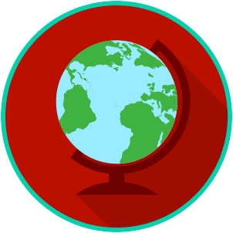
Name: _______________________

Date: ________________________
The U.S. and The World: SS.7.C.3.2
Systems of Government
VOCABULARY PRACTICE

Systems of Government

Write about your understanding of the different systems of government by explaining the connections between and among each of the terms in the concept circle.

How do the terms in the concept circle fit together?

