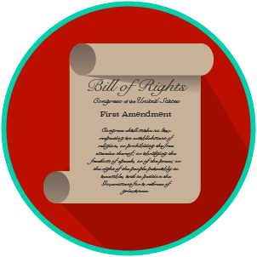
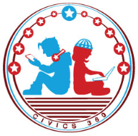
My Rights & Liberties: SS.7.C.3.6
Constitutional Rights and Their Impact
VIDEO VIEWING GUIDE #1
Name: ________________________________

Date: _________________________________

Constitutional Rights Video #1
Question | List Specific Evidence from the Video | Complete Sentence
1. What are constitutional rights?

2. Which documents protect constitutional rights in the United States?

3. What rights and freedoms are contained in the First Amendment?
4. What do we mean when we say our First Amendment rights are both political and social?
5. The Fourth, Fifth, and Fourteenth Amendments all protect citizens from abuse of power by the government.

How do the Fourth and Fifth differ from the Fourteenth?
6. What are three constitutional rights or protections of citizens?

7. What is due process?

8. What are our property rights as protected by the Constitution?

9. In what circumstance might the government be able to take your private property?
10. What is the restriction the government has if it wants to take your property for the public good?
11. Give an example of how the Constitution protects individual rights.

My Rights & Liberties: SS.7.C.3.6
Constitutional Rights and Their Impact
VIDEO VIEWING GUIDE #2
Name: ________________________________

Date: _________________________________

Impact of Constitutional Rights Video #2
Question | List Specific Evidence from the Video | Complete Sentence
1. What are some of the rights and protections included in the Constitution, Bill of Rights, and other Amendments?
2. What is due process?

3. How does the government balance individual liberties and rights with community protections?
4. When might it be necessary to limit individual rights and liberties?
5. What is habeas corpus?
6. How did Hosea Williams and John Lewis practice their rights?

7. What rights were Williams, Lewis, and the Selma Marchers practicing in 1965?

8. How did Executive Order 9066 impact American citizens?

9. Why is Fred Korematsu significant?
10. What was the outcome of Korematsu vs. United States? (1944)
11. Give an example of how the Constitution protects individual rights.
12. When might the government impose limits on individual rights?

My Rights & Liberties: SS.7.C.3.6
Constitutional Rights and Their Impact
READING GUIDE #1
Name: _______________________

Date: ________________________

Reading: Rights and Participation

Benchmark Clarification 1: Students will recognize how individual rights shape involvement in the social, political, and economic systems.

Reading Task | Response
What ideas are presented in the reading?
What is the central idea of the reading?
Select two words or phrases that support the central idea.
How might this reading connect to your own experience or something you have seen, read, or learned before?
How do individual rights shape involvement in social, political, and economic systems? | Individual rights shape involvement in social, political, and economic systems by:

My Rights & Liberties: SS.7.C.3.6
Constitutional Rights and Their Impact
READING GUIDE #2
Name: _______________________

Date: ________________________

Reading: Society and the Importance of Rights

Benchmark Clarification 2: Students will recognize how the social, political, and economic systems in the United States are dependent upon individual rights.

Reading Task | Response
What ideas are presented in the reading?
What is the central idea of the reading?
Select two words or phrases that support the central idea.
How might this reading connect to your own experience or something you have seen, read, or learned before?
Why do individual rights matter in the United States? | Individual rights matter in the US because:

My Rights & Liberties: SS.7.C.3.6
Constitutional Rights and Their Impact
READING GUIDE #3
Name: _______________________

Date: ________________________

Reading: Constitutional Rights Scenarios

Benchmark Clarification 3: Students will use scenarios to recognize and/or evaluate options for exercising constitutional rights.

Reading Task | Response
What ideas are presented in the reading?
What is the central idea of the reading?
Select two words or phrases that support the central idea.
How might this reading connect to your own experience or something you have seen, read, or learned before?
Create a scenario of your own that shows how we can exercise our constitutional rights.

My Rights & Liberties: SS.7.C.3.6
Constitutional Rights and Their Impact
READING GUIDE #4
Name: _______________________

Date: ________________________

Reading: The Impact of Government on Rights

Benchmark Clarification 4: Students will evaluate the impact of the government upholding and/or restricting individual constitutional rights.

Reading Task | Response
What ideas are presented in the reading?
What is the central idea of the reading?
Select two words or phrases that support the central idea.
How might this reading connect to your own experience or something you have seen, read, or learned before?
What must be balanced in order to determine whether to uphold or restrict individual rights? | In order to determine whether to uphold or restrict individual rights, the government must balance:

My Rights & Liberties: SS.7.C.3.6
Constitutional Rights and Their Impact
VOCABULARY PRACTICE
Name: _______________________

Date: ________________________

Constitutional Rights and Their Impact

Write about your understanding of constitutional rights by explaining the connections between and among each of the terms in the concept circle.

How do the terms in the concept circle fit together?

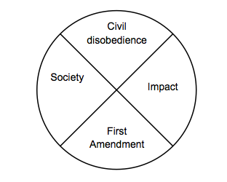

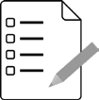
Name: ________________________

Date: _________________________
My Rights & Liberties: SS.7.C.3.6
Constitutional Rights and Their Impact
PRACTICE QUIZ
Constitutional Rights and Their Impact Practice Quiz Reflection

FIRST Attempt Score | I answered ______ questions right.
One thing I learned:

SECOND Attempt Score | I answered ______ questions right.
One thing I learned:

