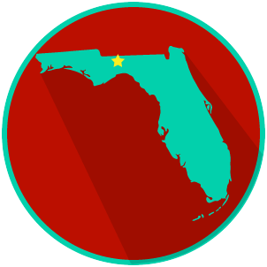
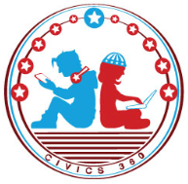
FL State & Local Government: SS.7.CG.3.12
Comparing Constitutions
VIDEO VIEWING GUIDE #1
Name: ______________________________

Date: _______________________________

Comparing the U.S. and Florida Constitutions Video #1
Question | List Specific Evidence from the Video | Complete Sentence
1. What is the Supreme Law of the Land?

2. What are four things that the U.S. Constitution does?

3. What are the 3 purposes of a constitution?
4. What are three ways that the structure of U.S. Constitution and the Florida Constitution are similar?
5. What is a preamble?

6. Why do both the U.S. Constitution and the Florida Constitution begin with ‘We the People’?
7. What is an article?
8. What is an amendment?
9. Where will we find the rights of Florida citizens in the Florida Constitution?
10. What is the Supremacy Clause?

