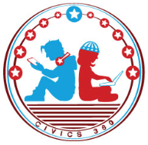
Federal Government: SS.7.CG.3.7
Structure, Powers & Processes of Federal Government
VIDEO VIEWING GUIDE #1
Name: ________________________________

Date: _________________________________

Legislative Branch: Structure and Lawmaking Video #1
Question | List Specific Evidence from the Video | Complete Sentence
1. Where are the structure and power of the legislative branch described?

2. According to the Constitution, what are the two houses of Congress?

3. What are elected members of the House of Representatives called?
4. What are elected members of the Senate called?
5. What term is used to describe both Senators and Representatives?

6. What is the main job of Congress?

7. Describe the lawmaking process as you have learned it so far.

8. Add to your description of the lawmaking process. What comes next?

