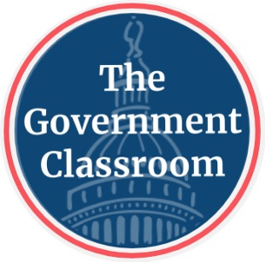  High School U.S. Government Classroom  The United States Constitution  VIDEO VIEWING GUIDE #2 | 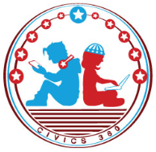  Name: ______________  Date: _______________

Question | List Specific Evidence  from the Video | Complete Sentence
1.What does Article I of the U.S. Constitution address?

2. What is the main power of the legislative branch under Article I?

3. What are the two houses of Congress?

4. What does Article II of the U.S. Constitution address?

5. How did the 22nd Amendment impact the executive branch?

6. What does Article III of the U.S. Constitution address?

7. What are the three levels of courts in the federal system, from lowest to highest?

8. What is the main power of the courts?

9. List two examples of checks and balances.

10. What article of the US Constitution could this political cartoon symbolize?

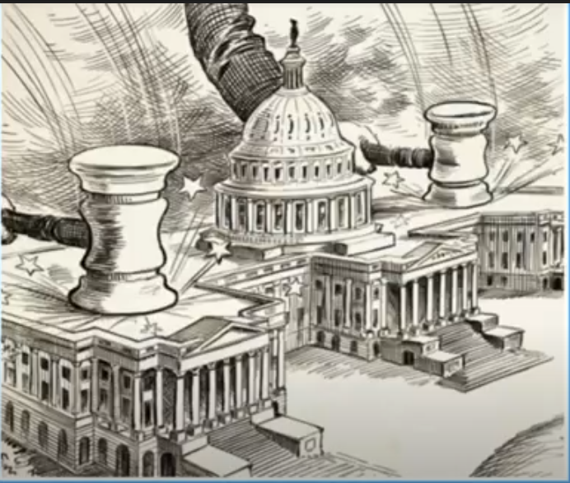
Congress Will Come to Order! by, Clifford K. Berryman

11. Match the branch of government with the image of the Article from the Constitution:

Judicial Branch, Executive Branch, Legislative Branch

