Article III
The Judicial Branch

- I can recognize the structure of the judicial branch.
- I can identify the powers described in Article III in the U.S. Constitution.

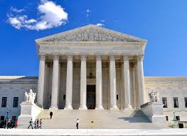
The U.S. Constitution is a document that outlines the structure and function of the United States government. The Framers’ of the U.S. Constitution believed they needed to create a new government system to fix problems in the Articles of Confederation. They also wanted to protect citizens’ individual rights. These beliefs led to the creation of Articles I, II and III of the U.S. Constitution. These articles create the three branches of government. Each article covers one branch.

Article III creates the judicial branch and describes its purpose and function. The judicial branch was created to interpret and analyze laws created by Congress and enforced by the executive branch.
Supreme Court & Lower Courts
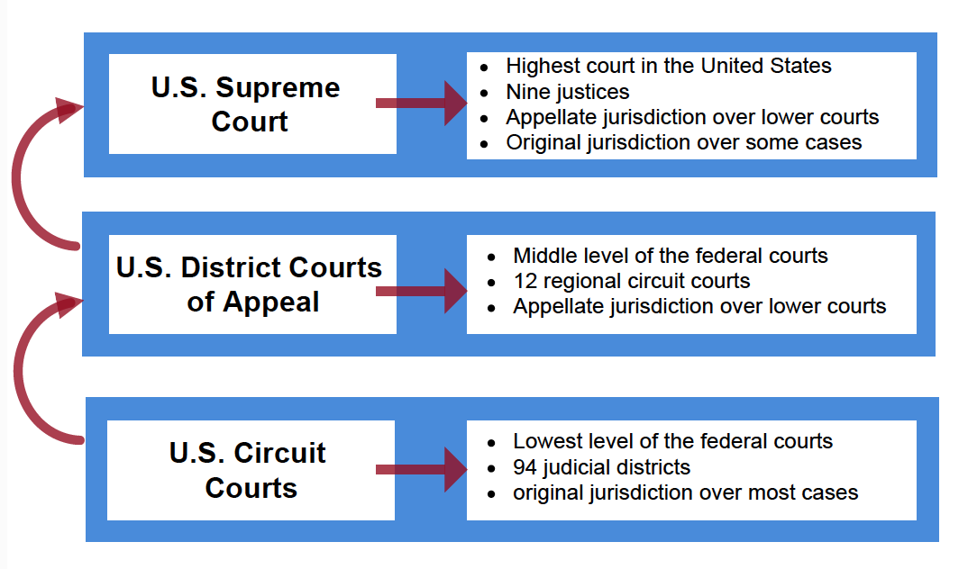
At the highest level of the judicial branch is the Supreme Court. It consists of nine justices who were all appointed by a U.S. president. The head justice of the Supreme Court is called the Chief Justice.
As the highest court in the land, the job of the Supreme Court is to review laws or government actions. The Supreme Court determines whether laws or actions are constitutional or unconstitutional.
The lower courts are courts under the Supreme Court. These courts are at the federal, state and local levels of government. Each lower court serves a particular jurisdiction while either operating as a trial court or appellate court. The chart to the right outlines the structure of the federal courts.

SUPREME POWERS
These are the powers of the Supreme Court:
Power of original jurisdiction (the power to be the first court to hear a case) for cases that involve:
- The constitutionality of federal and state laws
- Arguments between two or more states
- Problems that involve the U.S. government
- Ambassadors
All other cases not listed above come to the Supreme Court through their appellate jurisdiction.
The Supreme Court hears a case that has been heard by a lower court first.
The power of judicial review. The judicial branch can review the actions of the executive and legislative branches and determine whether or not they are unconstitutional (this includes laws passed by Congress); the U.S. Supreme Court case Marbury v. Madison established this power.

