Article I
The Legislative Branch

- I can recognize the structure of the legislative branch.
- I can identify the powers described in Article I in the U.S. Constitution.

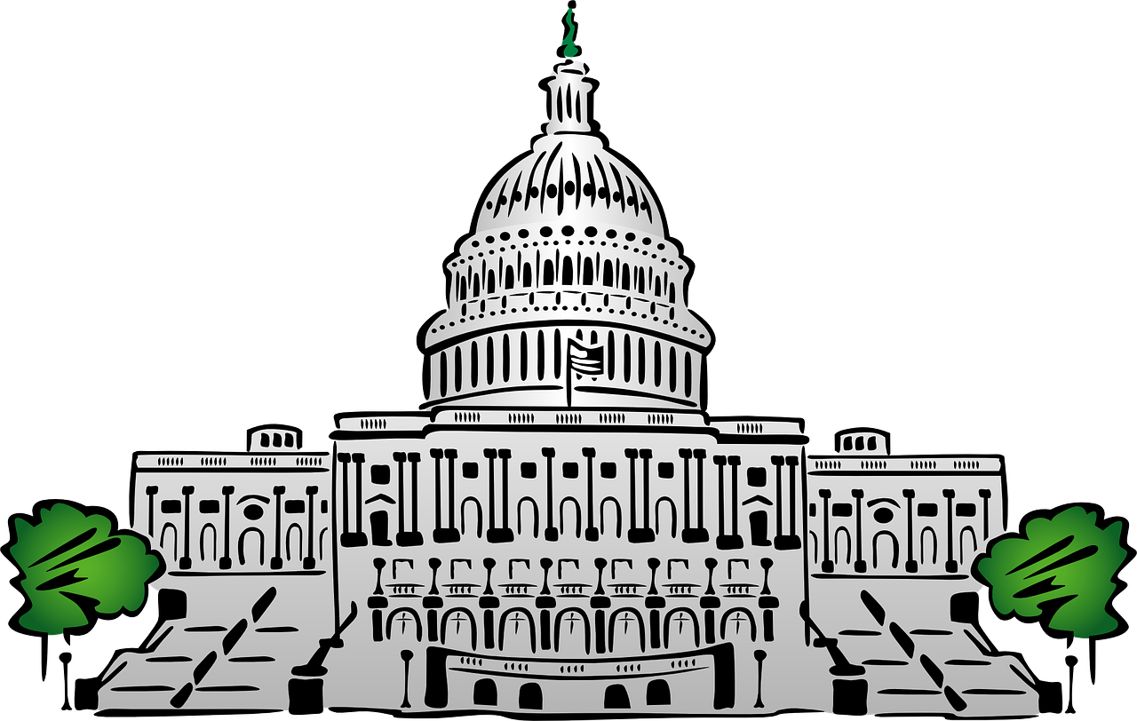
The U.S. Constitution is a document that outlines the structure and function of the United States government. The Framers’ of the U.S. Constitution believed they needed to create a new government system to fix problems in the Articles of Confederation. They also wanted to protect citizens’ individual rights. These beliefs led to the creation of Articles I, II and III of the U.S. Constitution. These articles create the three branches of government. Each article covers one branch.

Article I creates the legislative branch of government. The role of this branch is to make laws that help govern and protect each citizen’s rights and freedoms. The legislative branch creates laws that address issues and concerns of the entire country.
Congress!
The legislative branch is made up of a body of people called “Congress”. Congress is divided into two legislative (law-making) chambers called the “Senate” and “House of Representatives”.
  - The Senate is made up of 100 members. Two members represent each state. The leader of the Senate is the Vice President, but when he is not there the President Pro Tempore assumes the role of leader.
  - The House of Representatives consists of 435 members. Each member is elected by the citizens of a congressional district. States have different amounts of districts based on their population.

The leader of the House of Representatives is called the Speaker of the House and is elected by their peers in the House of Representatives. Those individuals who make up Congress are elected by the citizens of their state or respective communities. Their purpose is to address the concerns of the people by making laws.

Article I of the U.S. Constitution outlines:
- how Congress should be organized,
- the qualifications needed to be a member of the legislative branch,
- the frequency in which elections should be held for its members, and
- how often each chamber should meet as a group.

CONGRESSIONAL POWER
These are powers given by Article I to Congress:
power to collect taxes
power to coin money
power to make laws on immigration
power to make laws on trade
power to create an Army and Navy
power to impeach and remove officials from office
power to approve, or confirm, presidential appointments
power to use the Elastic Clause, which gives Congress the ability to pass laws that they deem necessary to carry out the powers enumerated in Article I

