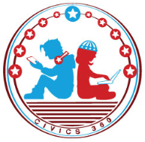
Federal Government: SS.7.CG.3.9
Structure, Functions, & Processes of the Judicial Branch
VIDEO VIEWING GUIDE #4
Name: ________________________________

Date: _________________________________

Judicial Branch Video
Question | List Specific Evidence from the Video | Complete Sentence
1. Where we will find information about the Judicial Branch?
2. What is meant by ‘original jurisdiction’?

3. What is meant by ‘appellate jurisdiction’?
4. What is a writ of certiorari?
5. Why is Marbury vs. Madison (1803) an important case?
6. What is judicial review?

7. How is judicial review a check on the legislative and judicial branches?

8. What is a court order?

9. What is a summary judgment?
10. Why might a judge issue a summary judgment?

