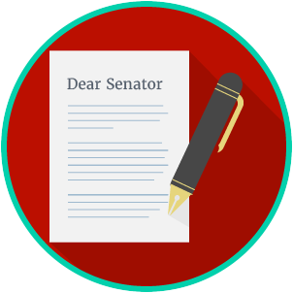
Engaged Citizens: SS.7.C.2.10
Influencing the Government
VOCABULARY PRACTICE
Name: ________________________

Date: _________________________
Influencing the Government

Write about your understanding of influencing and monitoring the government by explaining the connections between and among each of the terms in the concept circle.

How do the terms in the concept circle fit together?

