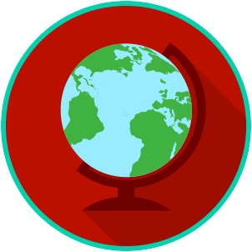
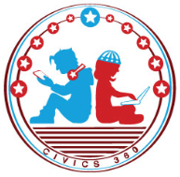
The U.S. & The World: SS.7.CG.4.2
International Organizations
VIDEO VIEWING GUIDE
Name: ________________________________

Date: _________________________________

Question | List Specific Evidence from the Video | Complete Sentence
1. What are international organizations?

2. What do we mean when we say an organization is an ‘intergovernmental organization’?
3. What is the purpose of the North Atlantic Treaty Organization (NATO)?
4. What is the goal of the United Nations?
6. What is the purpose of the United Nations Children’s Emergency Fund (UNICEF)?
7. What three areas does UNICEF focus on in order to try and fulfill its mission?
8. What is the goal of the World Trade Organization (WTO)?
9. What kind of policies does the WTO support in order to fulfill its mission?

10. How does the World Court contribute to the work of the United Nations?
11. How do international organizations play a role in trying to solve the problems facing the world?
12. What is an International Non-Governmental Organization (INGO)?
13. How might an INGO differ from International Governmental Organizations?
14. What are the four areas that INGO’s tend to focus on?
15. What is the purpose of the International Red Cross/Red Crescent?
16. How do nations become members of the United Nations?
17. What role does the General Assembly play at the United Nations?
18. What role does the Security Council play at the United Nations?
19. How can governments support the United Nations?
20. What are some ways that individuals can support the United Nations?
21. How can governments participate in the work of the World Court?
22. What are some ways that individuals can participate in the World Court?
23. How can individuals participate in and support the work of UNICEF?
24. How can governments support the International Red Cross/Red Crescent?
25. How can individuals support and participate in the work of the International Red Cross/Red Crescent?
26. Summarize the ways governments and individuals can support and participate in international organizations. | Governments
 | Individuals
27. What is a treaty?
28. How is the Geneva Convention an example of countries working together?
29. What are some examples of advantages to US membership in international organizations?
30. What are some examples of disadvantages to US membership in international organizations?

