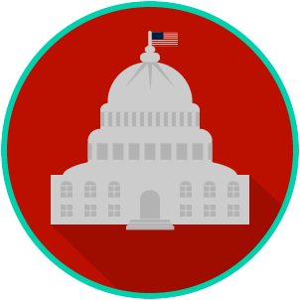
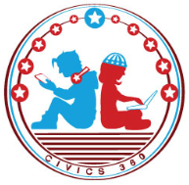
Federal Government: SS.7.C.1.7
Limits on Government Power
VIDEO VIEWING GUIDE
Name: ________________________________

Date: _________________________________

Question | List Specific Evidence from the Video | Complete Sentence
1. What is constitutional government based on?

2. What limits the powers of state and federal government?

3. What is the purpose of limited government?
4. Why is power divided between the three branches of government?
5. Identify the role and responsibility of each of the three branches of government:
5a. Legislative:
5b. Executive:
5c. Judicial:
6. What is judicial review?

7. Define ‘separation of powers’ in your own words.

8. Define ‘checks and balances’ in your own words.
9. Provide an example of the ways in which each branch can check and balance the actions of another branch:
9a. Executive:
9b. Legislative:
9c. Judicial:
10. How do the concepts of separation of powers and checks and balances limit the power of government?

Name: _______________________

Date: ________________________
Federal Government: SS.7.C.1.7
Limits on Government Power
READING GUIDE #1
Reading: Limited Government

Benchmark Clarification 1: Students will explain the concept of limited government as set forth in the U.S. Constitution.

Reading Task | Response
What ideas are presented in the reading?
What is the central idea of the reading?
Select two words or phrases that support the central idea.
How might this reading connect to your own experience or something you have seen, read, or learned before?
Explain the concept of limited government as set forth in the U.S. Constitution. | The concept of limited government as set forth in the U.S. Constitution is:

Name: _______________________

Date: ________________________
Federal Government: SS.7.C.1.7
Limits on Government Power
READING GUIDE #2
Reading: Distinguishing Between Separation of Powers and Checks and Balances

Benchmark Clarification 2: Students will describe and distinguish between the concepts of separation of powers and checks and balances.

Reading Task | Response
What ideas are presented in the reading?
What is the central idea of the reading?
Select two words or phrases that support the central idea.
How might this reading connect to your own experience or something you have seen, read, or learned before?
Describe the concepts of separation of powers and checks and balances. How do they differ? | The concept of separation of powers is:
 | The concept of checks and balances is:
 | These two concepts differ by:

Name: _______________________

Date: ________________________
Federal Government: SS.7.C.1.7
Limits on Government Power
READING GUIDE #3
Reading: How Checks and Balances and Separation of Powers Limit Government

Benchmark Clarification 3: Students will analyze how government power is limited by separation of powers and/or checks and balances.

Reading Task | Response
What ideas are presented in the reading?
What is the central idea of the reading?
Select two words or phrases that support the central idea.
How might this reading connect to your own experience or something you have seen, read, or learned before?
How does the Constitution limit government power? | The Constitution limits government power by:

Name: _______________________

Date: ________________________
Federal Government: SS.7.C.1.7
Limits on Government Power
READING GUIDE #4
Reading: Examples of Limited Government

Benchmark Clarification 4: Students will be able to recognize examples of separation of powers and checks and balances.

Reading Task | Response
What ideas are presented in the reading?
What is the central idea of the reading?
Select two words or phrases that support the central idea.
How might this reading connect to your own experience or something you have seen, read, or learned before?
Provide two examples of separation of powers and two examples of checks and balances. | Separation of Powers Examples:
 | Checks and Balances Examples:

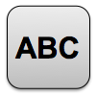
Name: _______________________

Date: ________________________
Federal Government: SS.7.C.1.7
Limits on Government Power
VOCABULARY PRACTICE

Limits on Government Power

Write about your understanding of how the Constitution limits the powers of government by explaining the connections between and among each of the terms in the concept circle.

How do the terms in the concept circle fit together?

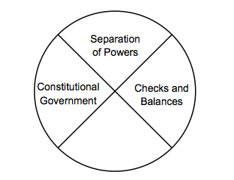

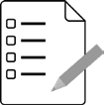
Name: _______________________

Date: ________________________
Federal Government: SS.7.C.1.7
Limits on Government Power
PRACTICE QUIZ
Limits on Government Power Practice Quiz Reflection

FIRST Attempt Score | I answered ______ questions right.
One thing I learned:

SECOND Attempt Score | I answered ______ questions right.
One thing I learned:

