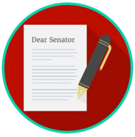
Engaged Citizens: SS.7.CG.2.9
Bias, Symbolism, and Propaganda
READING #1
Name: ________________________

Date: _________________________

SS.7.CG.2.9 Benchmark Clarification 1: Students will use scenarios to identify bias, symbolism and propaganda.

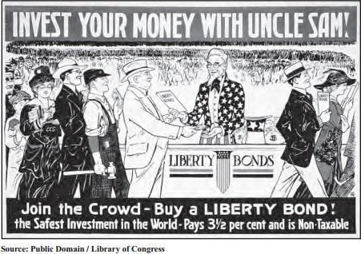
The poster below was created in 1917.

This poster was created in 1917, during World War I. This is an example of the government using
symbolism and propaganda to influence citizens.

In the poster, one can see “Uncle Sam” selling “liberty bonds” (money that the government borrowed from the citizens to fund and support the military during World War I). The cartoonist used Uncle Sam (the first two letters in Uncle Sam are “U” and “S”) to represent the United States. The idea was to get the readers to think it was their patriotic duty to buy these bonds to support the war. The symbolism (Uncle Sam) and propaganda (“Invest Your Money in the War”) used in this cartoon were effective ways to make citizens think or behave in a certain way.
The political cartoon below was created in 1754.
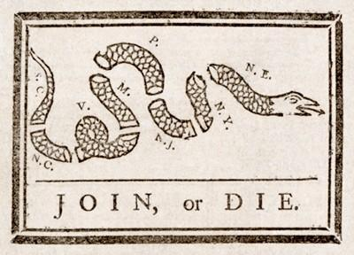

Each of the eight parts of the snake represents a region or colony. For example, “N.E.” stands for “New England,” which included four colonies. “P.” stands for Pennsylvania, which included Delaware at the time (Georgia was not included.). The phrase “Join, or Die” was the artist’s message that unity was important to the colonists’ survival. The artist’s bias is seen by the support for the colonies to come together (“join”) with Great Britain against the French and Indians during the French and Indian War. If they didn’t, they would not survive (“die”). The “Join, or Die” symbol was later used to encourage the colonists to support independence from Great Britain during the American Revolutionary War.

bias - a preference, opinion or attitude that favors one way of thinking or feeling over another
propaganda - the method of spreading ideas or information for the purpose of helping or hurting an institution, a cause, or a person
symbolism - the use of something to represent ideas or qualities

