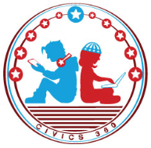
The Judicial Branch: SS.7.CG.3.9
The Appellate Process
VIDEO VIEWING GUIDE
Name: ________________________________

Date: _________________________________

Question | List Specific Evidence from the Video | Complete Sentence
1. When does the appellate process begin?

2. Explain the difference between the petitioner and the respondent.
3. Describe the only four reasons an appeals court might hear a case.
4. How is the appellate process different from a criminal or civil trial?
5. What are the 3 possible outcomes of an appeals court decision?
6. If a petitioner disagrees with the outcome of an appeals court decision, what is the final step he or she can take?
7. Summarize the appellate process in your own words.

