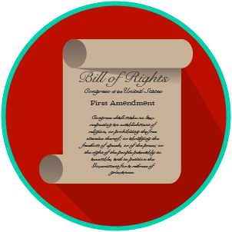
My Rights & Liberties: SS.7.CG.2.3
The Bill of Rights and
Other Amendments
VIDEO VIEWING GUIDE #2
Name: ________________________________

Date: _________________________________

The Bill of Rights and Amendments 2-10 Video #2
Question | List Specific Evidence from the Video | Complete Sentence
1. What are the big ideas in the following amendments? | Amendment 2:
 | Amendment 3:
 | Amendment 4:
2. What are the three big ideas in the 5th Amendment?

3. Why is due process an important civil right?
4. How does protection against self- incrimination support the right to due process?
5. What are the big ideas in the following amendments? | Amendment 6:
 | Amendment 7:
 | Amendment 8:
 | Amendment 9:
 | Amendment 10:
6. Why does the 9th Amendment add to constitutional rights and liberties?

Extra Notes Section

