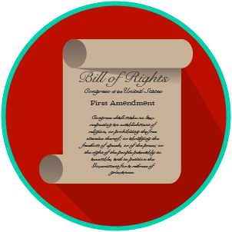
My Rights & Liberties: SS.7.C.3.7
Voting Rights
VOCABULARY PRACTICE
Name: _______________________

Date: ________________________

Voting Rights

Write about your understanding of voting rights by explaining the connections between and among each of the terms in the concept circle.

How do the terms in the concept circle fit together?

