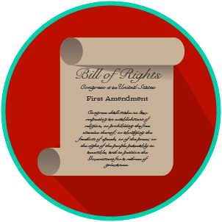
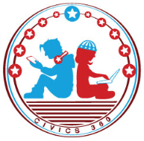
My Rights & Liberties: SS.7.C.2.5
Protecting and Limiting Rights
VIDEO VIEWING GUIDE #1
Name: ________________________________

Date: _________________________________
Protecting Our Rights Video #1
Question | List Specific Evidence from the Video | Complete Sentence
1. Why didn’t the Founding Fathers believe the Constitution needed a Bill of Rights?

2. What rights will we find in Article I, Section Nine of the U.S. Constitution?

3. Explain the concept of habeas corpus
4. How does banning ex post facto law protect our rights?
5. Why did the Founding Fathers create an independent judiciary?

6. What does Article III of the U.S. Constitution cover?
7. What is the appellate process?
8. How does an independent judiciary safeguard our rights?
9. How does the Constitution protect (safeguard) our rights outside of the Bill of Rights?

Extra Notes Section

My Rights & Liberties: SS.7.C.2.5
Protecting and Limiting Rights
VIDEO VIEWING GUIDE #2
Name: ________________________________

Date: _________________________________
Limits on Rights Video #2
Question | List Specific Evidence from the Video | Complete Sentence
1. How does the Constitution protect (safeguard) our rights outside of the Bill of Rights?

2. Why might individuals not be able to use their freedoms as much as they like?

3. What are the rights in the First Amendment?
4. What do courts and the government have to balance when it comes to our rights?
5. If we are at war, why might there be limits on free speech?

6. If there is a riot or national disaster, why might your right to assemble be limited?
7. Why can’t you shout ‘fire’ in a crowded theater if there is no fire?
8. Why might our rights be limited?
9. Provide an example that reflects each of the following standards that the courts use to determine whether a right can be limited:
9a. Clear and Present Danger
9b. Fighting Words
9c. Libel
9d. Conflict with government interests:
10. What must the courts ask when determining whether rights can be limited?

Name: _______________________

Date: ________________________
My Rights & Liberties: SS.7.C.2.5
Protecting and Limiting Rights
READING GUIDE #1

Reading: Limited Rights

Benchmark Clarification 1: Students will recognize that rights are protected, but are not unlimited.

Reading Task | Response
What ideas are presented in the reading?
What is the central idea of the reading?
Select two words or phrases that support the central idea.
How might this reading connect to your own experience or something you have seen, read, or learned before?
In what way does the Constitution ensure that rights are protected but not unlimited? | The Constitution ensures that rights are protected but not unlimited by:

Name: _______________________

Date: ________________________
My Rights & Liberties: SS.7.C.2.5
Protecting and Limiting Rights
READING GUIDE #2

Reading: Why Rights Are Limited

Benchmark Clarification 2: Students will examine rationales for limiting individual rights.

Reading Task | Response
What ideas are presented in the reading?
What is the central idea of the reading?
Select two words or phrases that support the central idea.
How might this reading connect to your own experience or something you have seen, read, or learned before?
What are some reasons for limiting individual rights? | Some reasons for limiting individual rights are:

Name: _______________________

Date: ________________________
My Rights & Liberties: SS.7.C.2.5
Protecting and Limiting Rights
READING GUIDE #3

Reading: The Impact of Limited Rights

Benchmark Clarification 3: Students will use scenarios to examine the impact of limits on individual rights on social behavior.

Reading Task | Response
What ideas are presented in the reading?
What is the central idea of the reading?
Select two words or phrases that support the central idea.
How might this reading connect to your own experience or something you have seen, read, or learned before?
Create a scenario of your own that shows the impact of limits on individual rights.

Name: _______________________

Date: ________________________
My Rights & Liberties: SS.7.C.2.5
Protecting and Limiting Rights
READING GUIDE #4

Reading: Rights and the Judicial Branch

Benchmark Clarification 4: Students will examine the role of the judicial branch of government in protecting individual rights.

Reading Task | Response
What ideas are presented in the reading?
What is the central idea of the reading?
Select two words or phrases that support the central idea.
How might this reading connect to your own experience or something you have seen, read, or learned before?
How does the judicial branch protect individual rights? | The judicial branch protects individual rights by:

My Rights & Liberties: SS.7.C.2.5
Protecting and Limiting Rights
VOCABULARY PRACTICE
Name: _______________________

Date: ________________________

Protecting and Limiting Rights

Write about your understanding of individual rights by explaining the connections between and among each of the terms in the concept circle.

How do the terms in the concept circle fit together?
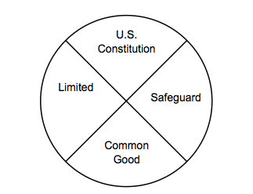

My Rights & Liberties: SS.7.C.2.5
Protecting and Limiting Rights
PRACTICE QUIZ
Name: _______________________

Date: ________________________
Protecting and Limiting RIghts Practice Quiz Reflection

FIRST Attempt Score | I answered ______ questions right.
One thing I learned:

SECOND Attempt Score | I answered ______ questions right.
One thing I learned:

