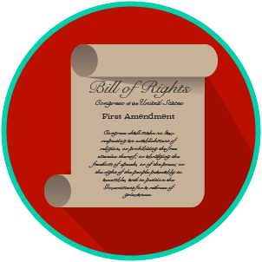
My Rights & Liberties: SS.7.C.2.4
The Bill of Rights and
Other Amendments
READING GUIDE #1
Name: _______________________

Date: ________________________

Reading: The Bill of Rights Comprises the First Ten Amendments

Benchmark Clarification 1: Students will recognize that the Bill of Rights comprises the first ten amendments to the U.S. Constitution.

Reading Task | Response
What ideas are presented in the reading?
What is the central idea of the reading?
Select two words or phrases that support the central idea.
How might this reading connect to your own experience or something you have seen, read, or learned before?
What is the Bill of Rights? | The Bill of Rights is:

