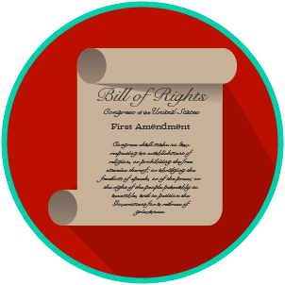
My Rights & Liberties: SS.7.C.2.4
The Bill of Rights and
Other Amendments
READING GUIDE #2
Name: _______________________

Date: ________________________

Reading: The Five Freedoms Protected by the First Amendment

Benchmark Clarification 2: Students will recognize the five freedoms protected by the First Amendment.

Reading Task | Response
What ideas are presented in the reading?
What is the central idea of the reading?
Select two words or phrases that support the central idea.
How might this reading connect to your own experience or something you have seen, read, or learned before?
What are the five freedoms protected by the First Amendment? | The five freedoms protected by the First Amendment are:

