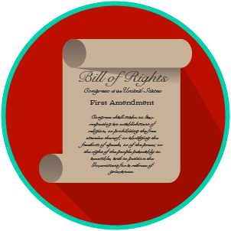
My Rights & Liberties: SS.7.C.2.4
The Bill of Rights and
Other Amendments
READING GUIDE #3
Name: _______________________

Date: ________________________

Reading: How the Bill of Rights Influences Actions and Interactions

Benchmark Clarification 3: Students will evaluate how the Bill of Rights influences individual actions and social interactions.

Reading Task | Response
What ideas are presented in the reading?
What is the central idea of the reading?
Select two words or phrases that support the central idea.
How might this reading connect to your own experience or something you have seen, read, or learned before?
How does the Bill of Rights influence individual actions and social interactions? | The Bill of Rights influences individual actions and social interactions by:

