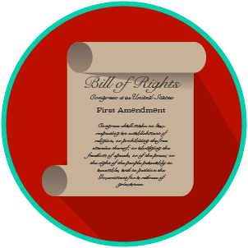
My Rights & Liberties: SS.7.C.2.4
The Bill of Rights and
Other Amendments
READING GUIDE #4
Name: _______________________

Date: ________________________

Reading: Scenarios that identify rights protected by the Bill of Rights

Benchmark Clarification 4: Students will use scenarios to identify rights protected by the Bill of Rights.

Reading Task | Response
What ideas are presented in the reading?
What is the central idea of the reading?
Select two words or phrases that support the central idea.
How might this reading connect to your own experience or something you have seen, read, or learned before?
Create your own scenario that shows a right protected by the Bill of Rights.

