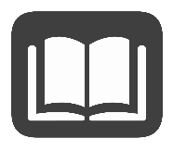
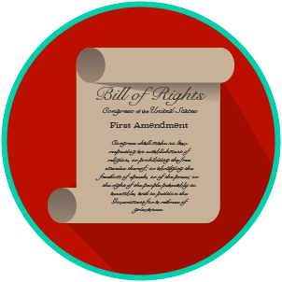
My Rights & Liberties: SS.7.C.2.4
The Bill of Rights and
Other Amendments
READING GUIDE #5
Name: _______________________

Date: ________________________

Reading: Scenarios That Identify Violations of Constitutional Amendments

Benchmark Clarification 5: Students will use scenarios to recognize violations of the Bill of Rights or other constitutional amendments.

Reading Task | Response
What ideas are presented in the reading?
What is the central idea of the reading?
Select two words or phrases that support the central idea.
How might this reading connect to your own experience or something you have seen, read, or learned before?
Create your own scenario that shows a violation of a right listed in the Bill of Rights or another constitutional amendment.

