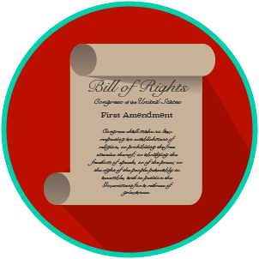
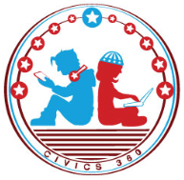
My Rights & Liberties: SS.7.CG.3.6
Voting Rights
VIDEO VIEWING GUIDE #1
Name: ________________________________

Date: _________________________________
The Amendments Video #1
1. Complete the chart as you watch the video:

Amendment | Purpose
13th Amendment
14th Amendment
Equal Protection Clause of the 14th Amendment
15th Amendment
19th Amendment
24th Amendment
26th Amendment

Question | List Specific Evidence from the Video | Complete Sentence
2. After the 15th Amendment, who was allowed to vote?

3. If an election was held after the 15th Amendment was ratified, which groups of people could NOT vote in that election?
4. What was the purpose of the poll tax?
5. If an election was held after the 26th amendment was ratified, which groups of people could vote in that election?

Extra Notes Section

