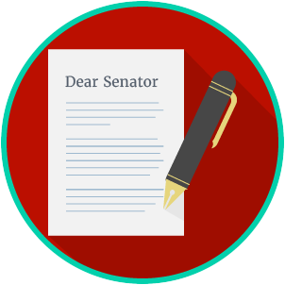
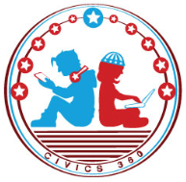
Engaged Citizens: SS.7.C.2.12
Public Policy Problem Solving
VIDEO VIEWING GUIDE
Name: ________________________________

Date: _________________________________

Question | List Specific Evidence from the Video | Complete Sentence
1. What are public policies?

2. What kind of problems would local governments try to solve?

3. What kind of problems would state governments try to solve?
4. What kind of problems would the federal governments try to solve?
5. Why do lawmakers look at several possible solutions before choosing the one that will solve a problem?

6. What is a public agency?
7. Based on what you have learned, what is the role of government agencies in solving public problems?
8. What is the difference between government solutions to problems and individual or community solutions?

Engaged Citizens: SS.7.C.2.12
Public Policy
Problem Solving
READING GUIDE #1
Name: ________________________

Date: _________________________
Reading: Understanding Levels of Government

Benchmark Clarification 1: Students will identify the appropriate level of government to resolve specific problems.

Reading Task | Response
What ideas are presented in the reading?
What is the central idea of the reading?
Select two words or phrases that support the central idea.
How might this reading connect to your own experience or something you have seen, read, or learned before?
Give one example of a problem that might be solved at local level, one at the state level, and one at the federal level of government. | Local:
 | State:
 | Federal:

Engaged Citizens: SS.7.C.2.12
Public Policy
Problem Solving
READING GUIDE #2
Name: ________________________

Date: _________________________
Reading: Government Agencies

Benchmark Clarification 2: Students will identify appropriate government agencies to address state or local problems.

Reading Task | Response
What ideas are presented in the reading?
What is the central idea of the reading?
Select two words or phrases that support the central idea.
How might this reading connect to your own experience or something you have seen, read, or learned before?
How do you decide what government agency should address a state or local problem? | You decide what government agency you should ask to help solve a problem by:

Engaged Citizens: SS.7.C.2.12
Public Policy
Problem Solving
READING GUIDE #3
Name: ________________________

Date: _________________________
Reading: Analyzing Public Policy Alternatives

Benchmark Clarification 3: Students will analyze public policy alternatives to resolve state and local problems.

Reading Task | Response
What ideas are presented in the reading?
What is the central idea of the reading?
Select two words or phrases that support the central idea.
How might this reading connect to your own experience or something you have seen, read, or learned before?
Why do you think it is important to find alternative solutions to state and local problems? | It is important to find alternative solutions to state and local problems because:

Engaged Citizens: SS.7.C.2.12
Public Policy
Problem Solving
READING GUIDE #4
Name: ________________________

Date: _________________________
Reading: Public Policy versus Private Community Solutions

Benchmark Clarification 4: Students will compare public policy solutions and private community service solutions.

Reading Task | Response
What ideas are presented in the reading?
What is the central idea of the reading?
Select two words or phrases that support the central idea.
How might this reading connect to your own experience or something you have seen, read, or learned before?
How do public policy solutions differ from private community solutions? | Public policy solutions differ from private community solutions in that:

Engaged Citizens: SS.7.C.2.12
Public Policy
Problem Solving
VOCABULARY PRACTICE
Name: ________________________

Date: _________________________
Public Policy Problem Solving

Write about your understanding of public policy by explaining the connections between and among each of the terms in the concept circle.

How do the terms in the concept circle fit together?

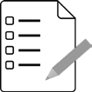
Engaged Citizens: SS.7.C.2.12
Public Policy
Problem Solving
PRACTICE QUIZ
Name: ________________________

Date: _________________________
Public Policy Problem Solving Practice Quiz Reflection

FIRST Attempt Score | I answered ______ questions right.
One thing I learned:

SECOND Attempt Score | I answered ______ questions right.
One thing I learned:

