High School U.S. Government Classroom  Principles of American Democracy  VIDEO VIEWING GUIDE #2 | Name: ______________  Date: _______________

Question | List Specific Evidence  from the Video | Complete Sentence
1.What are the two important principles emphasized by the Enlightenment?
2. How did Locke and Montesquieu influence American democratic principles?
3. Explain how this quote from Montesquieu is reflected in the US Constitution:
“There is as yet no liberty if the power of judging be not separated from legislative power and the executive power”.
4. What is the principle of American democracy that prevents the government from abusing its power?
5. Use the provided chart to answer the question below:
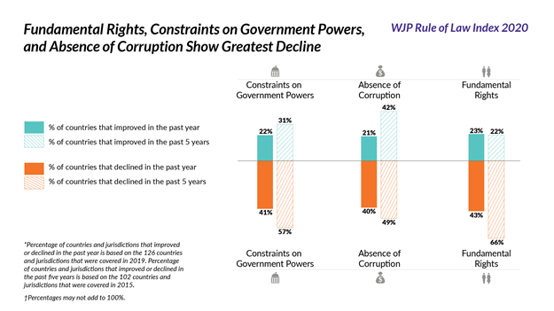
Which aspect of rule of law has declined over the past five years?

6. How does the United States ensure the rule of law?

