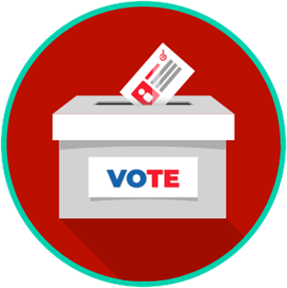
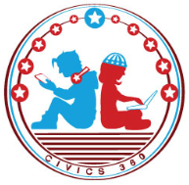
Voting and Elections: SS.7.CG.2.6
Political Parties
VIDEO VIEWING GUIDE
Name: ________________________________

Date: _________________________________
Elections and Voting
Question | List Specific Evidence from the Video | Complete Sentence
1. How do you think George Washington felt about the idea of political parties? Why?

2. What were the first two political parties in the United States?

3. Who were two leaders of the Democratic-Republicans?
4. What are three things that the Democratic-Republicans supported?
5. What is one thing that the Democratic-Republicans opposed?
6. Who were two of the first leaders of the Democratic Party?
7. What are three things that the Democratic Party of 1828 supported?
8. What is one thing that the Democratic Party of 1828 opposed?
9. What position did the Democratic Party of 1828 take on slavery?
10. What region or regions of the United States provided strong support for the Democratic Party until the late 20th century?
11. How might the Democratic Party of the modern day be described?
12. Who were two leaders of the Federalist Party?
13. What are three things that the Federalist Party supported?
14. Who are two leaders of the Whig Party?
15. What are three things that the Whigs supported?
16. What are two things that the Whigs opposed?

17. What position did the Whigs take on slavery?

18. What region or regions of the United States supported the early Republican Party?

19. Who were two leaders of the Republican Party at its founding?

20. What was the Republican Party’s position on slavery?

21. What party and president helped lead the United States through the Civil War?

22. What are three things that the Republican Party supported after its founding?

23. How might the Republican Party of the modern day be described?

24. How can political parties shape or impact public policy?

25. What are at least two other current political parties?
26. Are citizens required to join a political party to vote or participate in civic life?

