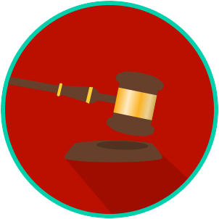
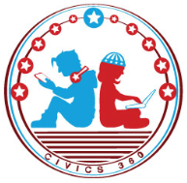
The Legal System: SS.7.CG.2.5
The Trial Process and Juries Criminal Trials
VIDEO VIEWING GUIDE
Name: ________________________________

Date: _________________________________

Question | List Specific Evidence from the Video | Complete Sentence
1. What type of law is criminal law?

2. What are Miranda rights?
3. Summarize what happens from when a suspect is arrested to his or her first appearance in court.
4. What is testimony?
5. Summarize the four steps of the criminal trial process.

6. In your own words, what are the purposes of the opening and closing statements?

