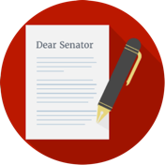 | Influencing the Government – Media, Individuals and Interest Groups  Methods
 | - I can identify and evaluate methods of influencing and monitoring government.

There are several different methods that individual citizens, the media and interest groups use to influence and monitor the government.
- Individuals can use their right to vote to change the government.
- The media can act as a watchdog to investigate and report on the government.
- Interest groups can hold meetings and write petitions to try to influence the government.

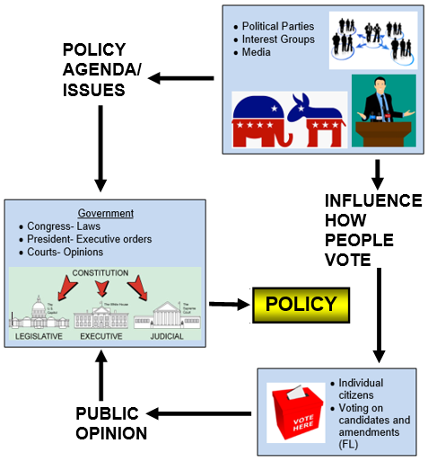
All of these people and groups are important members of a democratic society. They keep an eye on the government and hold its leaders accountable for what they do.

It is hard to know how effective each method is. This is because individuals, the media, and interest groups affect each other in their efforts to monitor and influence the government.

The media may focus their attention on a specific issue or campaign, which will attract public attention and may influence how people vote. Interest groups may spend money on an expensive public information campaign that also may influence how people vote and whether they will contribute money to the interest group.

Government leaders usually pay more attention to groups with a higher voting rate than they do to people who don’t vote often. Also, interest groups that spend a lot of money through their political action committees usually have a strong influence on who gets elected.

