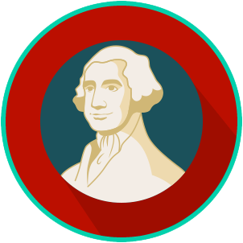
Founders’ Influences: SS.7.CG.1.2
Founding Principles
READING GUIDE #1
Name: ________________________

Date: _________________________

Reading: Founding Document Principles

Benchmark Clarification 1: Students will recognize principles contained in the founding documents (e.g., due process of law, equality of mankind, limited government, natural rights, the rule of law).

Reading Task | Response
What ideas are presented in the reading?
What is the central idea of the reading?
Select two words or phrases that support the central idea.
How might this reading connect to your own experience or something you have seen, read, or learned before?
Choose one principle outlined in the founding documents. Briefly explain this principle.

