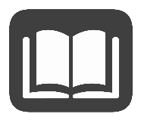
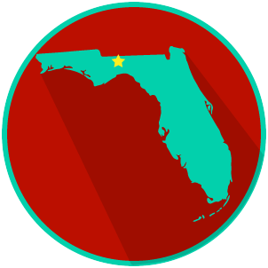
FL State & Local Government:
SS.7.C.3.13
Comparing Constitutions
READING GUIDE #4
Name: ______________________

Date: _______________________

Reading: Supreme Law of the Land

Benchmark Clarification 4: Students will compare the amendment process of the U.S. and Florida constitutions.

Reading Task | Response
What ideas are presented in the reading?
What is the central idea of the reading?
Select two words or phrases that support the central idea.
How might this reading connect to your own experience or something you have seen, read, or learned before?
What do we mean when we say the U.S. Constitution is the supreme law of the land? | When we say the U.S. Constitution is the supreme law of the land, we mean that:

